1.

ROM is read only memory, is a non volatile, permanent data which can only be read, not written.ran

RAM is random access memory which store data temporary

DRAM is cheaper but slower, SRAM is more expensive but faster

ROM is used for USB thumb drives. We can’t rely completely on that because of 3 reasons. External drives can be lost more easily, it can be more prone to error and external drives usually won’t be as quick as built-in storage devices.

2.

We need 8 192 000 000 bits

3.

Von Neumann is an old computer structure

Harvard is the newer computer structure

The Von Neumann uses the same physical memory address for instruction and data.

Harvard uses separated memory addresses for instruction and data.

The Von Neumann is used for personal computers and small computer

The Harvard is used for microcontrollers and signal processing.

4

Cache memory is a special high speed memory. It is used to speed up and match the speed of the CPU.

5.

Interrupts is a response to a signal that needs attention from the software.

There are hardware interrupts and software interruptions. maskable and non maskable interrupts

Polling isn’t used widely because it can waste time checking hardware, doesn’t take advantage of the stack and if one device freezes, it freezes the entire computer.

6

Stacks are the conceptually easiest way of saving info in a temporary storage.

It can refresh the interrupts more efficiently and faster

It allocates an array in memory and keeps variables with the array index number of the topmost active element.

11

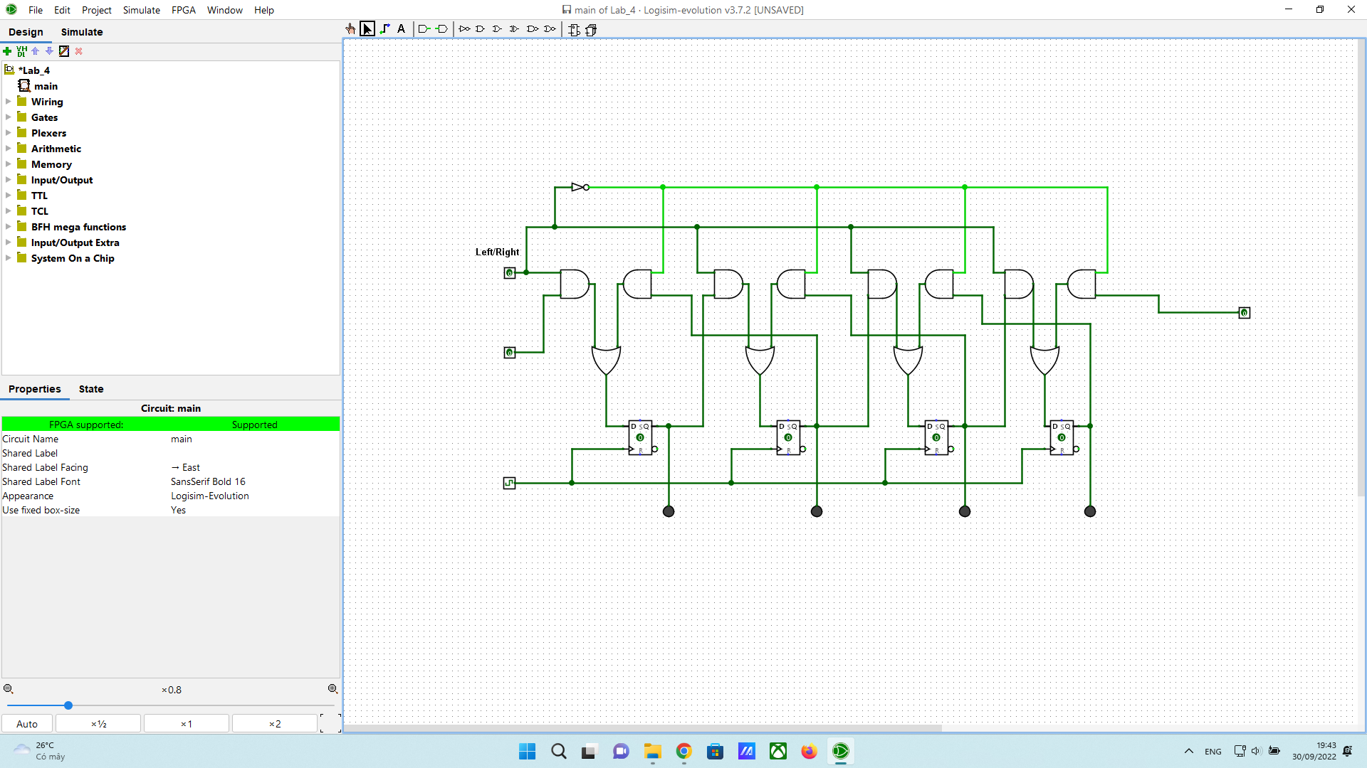

12

